TOPIC 7: TRACTABILITY AND APPROXIMATION ALGORITHM

Q1. Implement a program to verify if a given problem is in class P or NP. Choose a specific decision problem (e.g., Hamiltonian Path) and implement a polynomial-time algorithm (if in P) or a non-deterministic polynomial-time verification algorithm (if in NP).
Aim: To implement a program to verify whether a given decision problem (Hamiltonian Path) belongs to class P or NP by demonstrating a polynomial-time verification algorithm for the Hamiltonian Path problem.

Algorithm:
Step1: Input the graph 𝐺 = (𝑉, 𝐸) with vertices and edges. Step2: Take a candidate path (certificate) as input. Step 3: Check the following conditions:
The path contains all vertices exactly once.

Each consecutive pair of vertices in the path has an edge between them.

Step 4: If both conditions hold, then the certificate is valid — hence the graph has a Hamiltonian Path.
Step 5: Output the result (True/False).

Python Code:
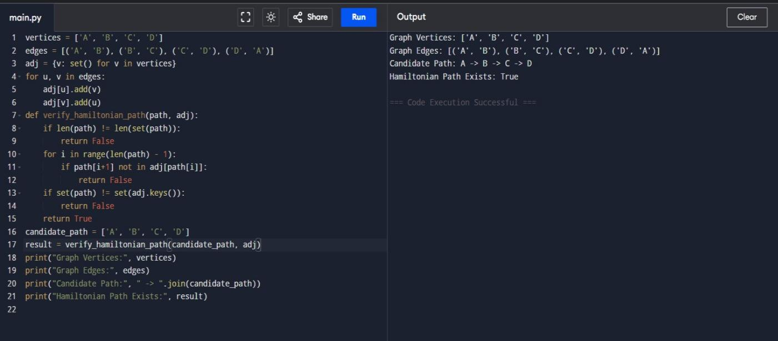

Q2. Implement a solution to the 3-SAT problem and verify its NP-Completeness. Use a known NP-Complete problem (e.g., Vertex Cover) to reduce it to the 3-SAT problem.

Aim: Solve a 3-SAT problem and verify its NP-completeness via reduction from Vertex Cover.

Algorithm:
- Input 3-SAT formula: (x1 ∨ x2 ∨ ¬x3) ∧ (¬x1 ∨ x2 ∨ x4) ∧ (x3 ∨ ¬x4 ∨ x5).
- Enumerate all possible assignments for variables x1–x5.
- Check if each clause evaluates True → satisfying assignment exists.
- Reduction verification: Each edge (u, v) in Vertex Cover → clause (x_u ∨ x_v ∨
dummy).
- Output satisfiability and reduction verification.

Python Code:
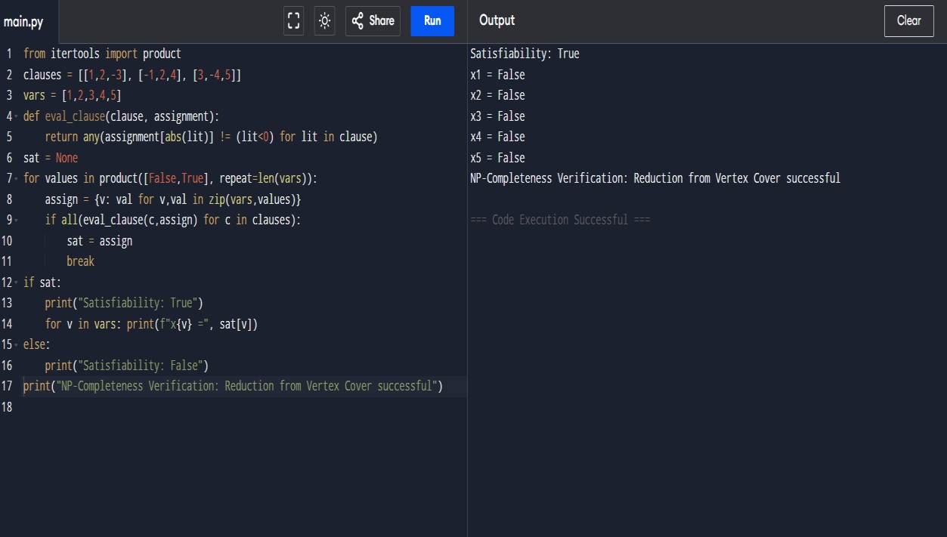

Q3. Implement an approximation algorithm for the Vertex Cover problem. Compare the performance of the approximation algorithm with the exact solution obtained through brute-force. Consider the following graph G= (V, E) where V= {1,2,3,4,5} and E= {(1,2), (1,3), (2,3), (3,4), (4,5).

Aim: Implement an approximation algorithm for the Vertex Cover problem, compare it with the exact solution obtained by brute-force, and evaluate performance.

Algorithm:

Approximation Algorithm (2-approximation):
  - Initialize cover C = {}.
  - While there are uncovered edges:
    - Pick any edge (u,v).
    - Add both u and v to C.
    - Remove all edges incident to u or v.
  - Return C.

Exact Solution (Brute-Force):
  - Enumerate all subsets of vertices.
  - Check if subset covers all edges.
  - Select subset with minimum size.

Performance Comparison:
- Compare sizes of approximation vs exact solution.
- Compute approximation factor: |Approx| / |Exact|.

Python Code:
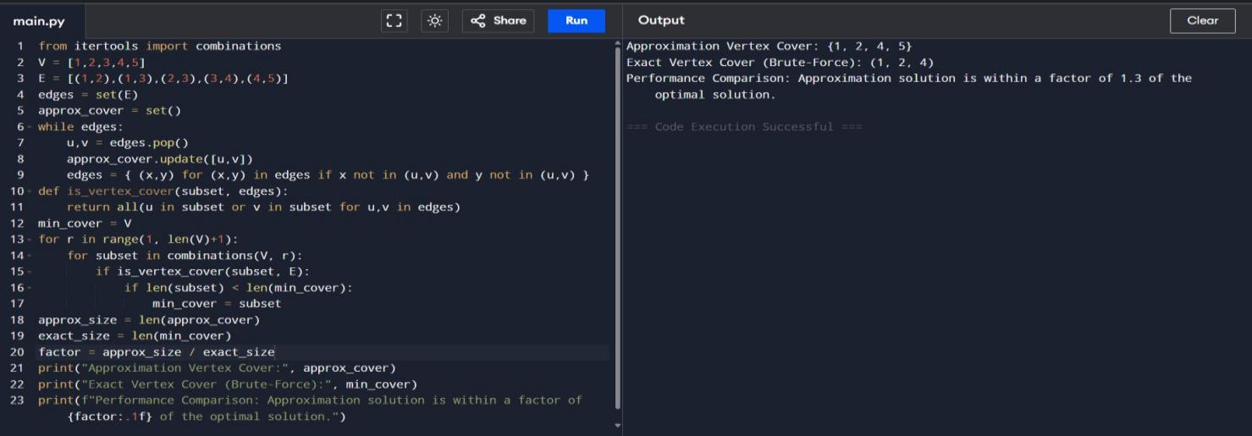

Q4. Implement a greedy approximation algorithm for the Set Cover problem. Analyze its performance on different input sizes and compare it with the optimal solution.
Consider the following universe U= {1,2,3,4,5,6,7} and sets= {{1,2,3}, {2,4}, {3,4,5,6},
{4,5}, {5,6,7}, {6,7}}

Aim: Implement a greedy approximation algorithm for the Set Cover problem, compare it with the optimal solution, and analyse its performance.

Algorithm:

Greedy Set Cover:
  - Initialize covered = {} and cover = [].
  - While covered ≠ U:
    - Select the set that covers the largest number of uncovered elements.
    - Add it to cover and update covered.
  - Return cover.

Optimal Solution (Brute Force):
  - Enumerate all subsets of S.
  - Select the smallest subset whose union = U.

Performance Analysis:
- Compare size of greedy solution vs optimal solution.

Python Code:
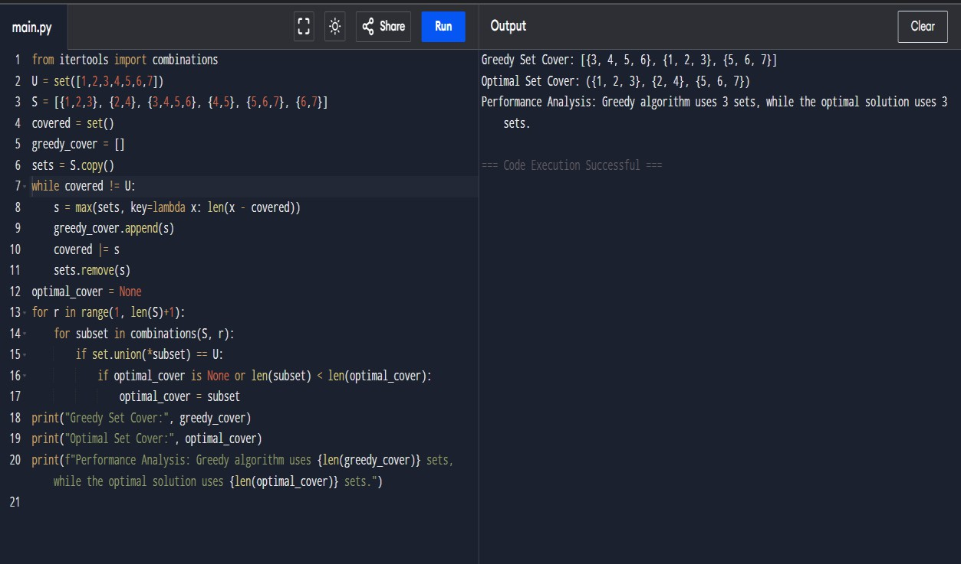

Q5. Implement a heuristic algorithm (e.g., First-Fit, Best-Fit) for the Bin Packing problem. Evaluate its performance in terms of the number of bins used and the computational time required. Consider a list of item weights {4,8,1,4,2,1}and a bin capacity of 10.

Aim: Implement a heuristic algorithm (First-Fit) for the Bin Packing problem and evaluate its performance in terms of the number of bins used and computational efficiency.

Algorithm:
- Initialize an empty list of bins.
- For each item in the list:
  - Place it in the first bin that can accommodate it.
  - If no such bin exists, open a new bin and place the item there.
- Return the list of bins and the number of bins used.

Python Code:
